**Detection of Brain Tumor using Convolution Neural Networks**

**Group – 38:**

**Nithish Reddy Emmadi - 0754724**

**Venkata Kalyan Ram Ghatti - 0756328**

**Priya Kandula – 0754438**

**Venkata Hanuman Sai Kumar Kaparaju - 0753837**

**Harish Veeramosu - 0755976**

**Abstract:**

We think there is a big problem in detection of brain tumor in easy and efficient way, to address this issue We decided to detect the brain tumor in an easy and simple way by deep learning image processing technique. We can also increase the accuracy by training the model with more diversified data, which would help in detecting tumor more accurately. This method would make the detection easily and reduce the death mortality by making use of medication.

**Introduction:**

A brain tumor is growth of abnormal cells in the brain. They are two types of tumors: malignant tumor (cancerous cells) and benign tumor(non-cancerous). while all the tumor produces different types of symptoms based upon the growth of cells with respective part of the body. When it comes to brain tumor the symptoms are most common ones, they are headache, vomiting, seizures. As the tumor progresses unconsciousness may occur. As these symptoms are most common in day-to-day life, there is chance of misunderstanding.

The cause of brain tumor is unknown from many past decades, but the only way to diagnosis the tumor is by detecting the tumor in its early stage. There is only a treatment for brain tumor in its early stage. So that tumor can respond to the medication. The tumor cells must be monitored and controlled very efficiently during its growth phase because it is the only way to make use of available medication. Brain tumor is more common in the children who cannot grasp the effects of brain tumor.

Cancer is the leading cause of death globally. The worst thing of cancer it can affect any part of the body. Cancer arises from the transformation of normal cells to tumor cells in a multistage process that progresses from benign tumor to malignant tumor. The main causes of cancer are tobacco use, overweight or obese, air pollution etc. it is most common in the developing countries due to vast use of urban utilities that cause pollution. When it comes to diagnosis it can done with the early stage of tumor which are awareness and accessing care, clinical evaluation, diagnosis and staging, and access to treatment. The primary goal of this diagnosis is to cure the tumor cells and prolong the life span of the respective person. There is chance of reappearance of the tumor in tumors this is due to non-responsiveness of some abnormal cells this can be reversed by monitoring the cells how they are reacting to the medication, and by changing the medication in appropriate time. For this purpose, we have decided to develop a technique which helps in detection of tumor in easy and efficient way. We are using deep learning technique which helps in detection of tumor in a shortest time possible by analyzing the tumor images.

**Benchmarks:**

This deep learning technique helps in classifying the brain tumor because of highest possible accuracy. Our model for detection of brain tumor is sets a benchmark in reducing the deaths due to tumor more significantly. This model is to adopt in any environment and cost effectively. We can also extend this to study the genome in tumor patient by studying the genome from different tumor effected.it helps in detecting the chance of disease causes in same genome family. Here we are going to use artificial neural networks which is image processing technique. This process helps in studying the tumors in 3D format in depth. This technique not only helps in detecting the brain tumor but also monitor the growth of tumor cells for effective use of medication

**Architecture of Convolution Neural Network:**

Zero padding layer: It is necessary to add a zero-padding layer to control the shrinkage of the dimensions after applying filters.

Convolutional layer: The usage of this layer with the help of 32 filters, is to convert all the images from input layers into a homogeneous dimension.

A batch normalization layer: It is helpful to each layer to learn more independently and, to increase the computation by normalizing the pixels.

ReLU activation function: Relu function is used as the activation function.

Max pooling layer: As we need to work with brain MRI images, so using max pooling layer will handle the problems of overfitting and computational cost.

Flatten layer: This layer converts the images stored as whole matrix into the single column vector.

Dense layer: The two dense layers of fully connected layers are created in the hidden layer. As the number of dimensions are proportional to computing resources, we have used the nodes moderately as per our resources.

**Methods:**

Dataset:

In detection of tumor, we collected images of both tumor and non-tumor images from various sources such as Kaggle, Google images etc.

We collected 155 tumor images and 98 non-tumor images to create a dataset.

Images of tumor are encoded as ‘yes’, and non-tumor images are encoded as ‘No’.

The collected images were of different size for processing, so we re-sized the images into (240,240). Furthermore, we created the resized images to training, validation, testing dataset i.e., 80% of training and 10% of validation and 10% of data for testing.

Skull Striping:

This technique helps us to filter out the unwanted area in an image. Using ‘OpenCV’ library we can achieve this method.

Firstly, we filter out the external noise from the image and look for the big contours in an image to remove the outer part of the brain.

Secondly, we find the extreme points in an image to locate the outer part and remove it.

Finally, we get the stripped image which can be used to build the model which can detect if the given image has tumor or not.

Data Augmentation:

We used Data Augmentation to generate more images to that the model can be trained to more data.

Using Data Augmentation, we can generate images with various variations of the given image.

Data Augmentation uses methods such as Randomflipping, RandomZoom, RandomShifting to generate multiple images with different variations.

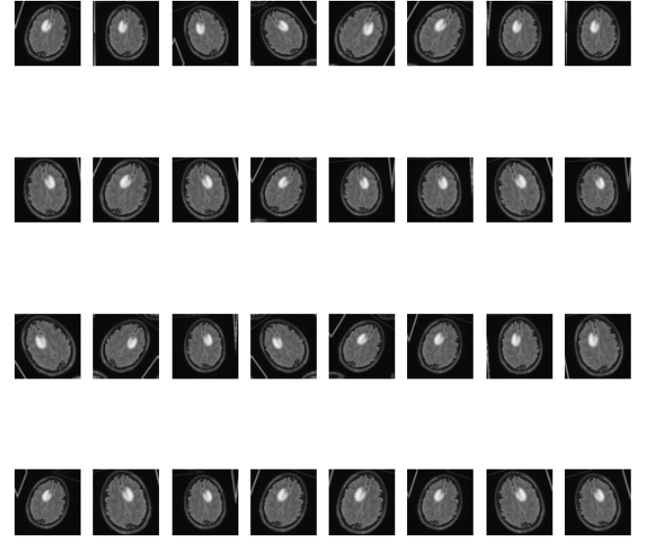By using Data Augmentation, we generated a total of 2065 images of which 980 are Non-Tumor images and 1085 are images containing Tumor.

Building a CNN Model:

We are using CNN architecture to extract the information from the image. We majorly use CNN for image classification, segmentation etc. In CNN we have convolution layers to extract the complex features. Training of CNN has selection of variety of different layers such as filter size, convolution stride, padding and a max-pooling layer to store features.

Before feeding the input images to the model we normalize the pixels to the range between 0 and 1.

After normalizing the pixels of the image, we feed the images of size 240,240.

We have convolution filters of size 3,3 with 32,64,64 filters.

A padding layer is needed to extract the information from the corners of the image. A Padding layer of size 2,2 is used.

A Relu activation layer is used for activating neurons.

A max-pooling layer of size 2,2 is used for storing important features.

A flatten layer is used to convert the 3D image to 1D image which takes input for sequential model.

A dense layer of 64 neurons is used for hidden layers.

An output dense layer of 1 neuron is used with sigmoid activation to find whether it is a tumor or non-tumor.

We are initializing the pre-trained weights with Adam optimizer and update the weights using binary cross entropy loss function.

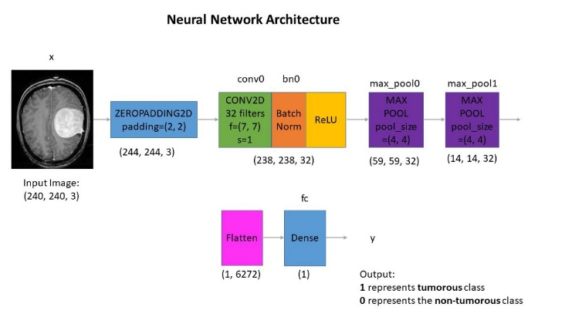

**Results:**

Using machine learning models, we will be able to predict if the given image has tumor or not. Using sigmoid function as a classifier,

We classified the given images with a label of ‘Yes’ and ‘No’ to indicate whether the given image is tumor or non-tumor.

Using 80% of available images to training, 10% for testing and 10% validation, the model built was 96% accurate in predicting the unknown images. When tested on validation data the model was 89% accurate in predicting the results.

|  |  |
| --- | --- |
| Predicted Accuracy of Unknown Images | 96% |
| Validation Accuracy in training the model | 89% |

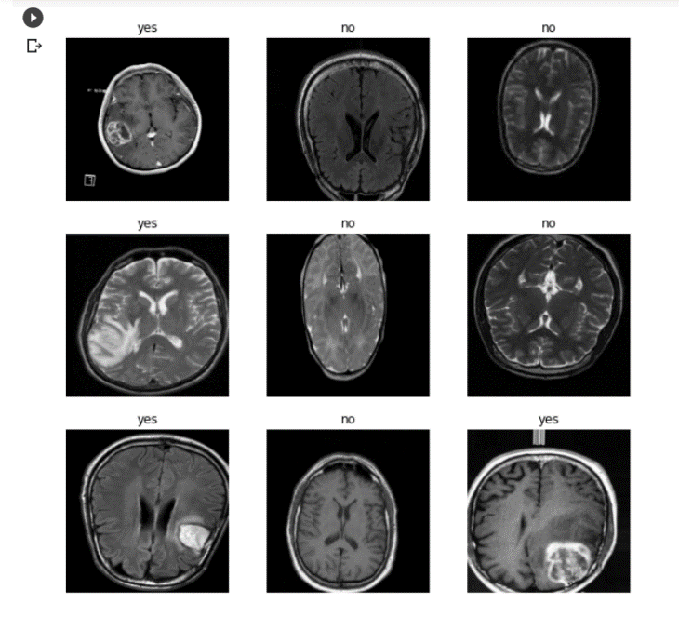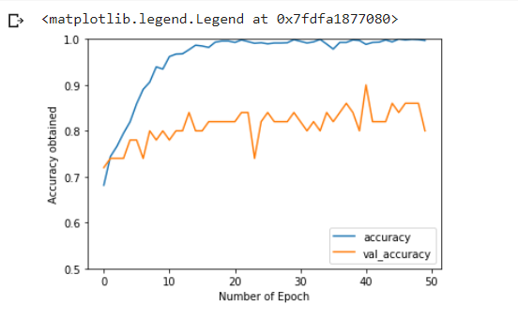

**Conclusion:**

Conventional data such as MRI and lab results were used to train the model to predict if any new given image contains tumor or not.

Following traditional laboratory methods is time consuming, this is where Machine learning comes into picture. This model bridges the gap and ensures that the patient is treated at the earliest with results from the trained data.

This model can be used to predict if a patient has tumor or not. Predicting it in very early stage can help the patient and the health care domain initiate the treatment procedures without any delay.

**Contributions:**

|  |  |
| --- | --- |
| Priya Kandula &  Venkata Hanuman Sai Kumar Kaparaju | * Collection of Tumor and Non-Tumor images * Classification of images * Building CNN Model |
| Nithish Reddy Emmadi | * Architecture of CNN Model * Skull Striping |
| Harish Veeramosu &  Venkata Kalyan Ram Ghatti | * Data Augmentation * Introduction and Problem statement |

**References:**

[1]:https://www.google.com/url?sa=i&url=https%3A%2F%2Ftowardsdatascience.com%2Fapplied-deep-learning-part-4-convolutional-neural-networks-584bc134c1e2&psig=AOvVaw1jEzHEB31j6GQAH-cclcJH&ust=1608489217031000&source=images&cd=vfe&ved=0CA0QjhxqFwoTCMDY1LnX2u0CFQAAAAAdAAAAABAD

[2]: <https://medium.com/@mohamedalihabib7/brain-tumor-detection-using-convolutional-neural-networks-30ccef6612b0>

[3]:https://www.researchgate.net/publication/337768246_Brain_Tumor_Detection_Using_Convolutional_Neural_Network

[4]:https://www.google.com/url?sa=i&url=https%3A%2F%2Ftowardsdatascience.com%2Fapplied-deep-learning-part-4-convolutional-neural-networks-584bc134c1e2&psig=AOvVaw1jEzHEB31j6GQAH-cclcJH&ust=1608489217031000&source=images&cd=vfe&ved=0CA0QjhxqFwoTCMDY1LnX2u0CFQAAAAAdAAAAABAD